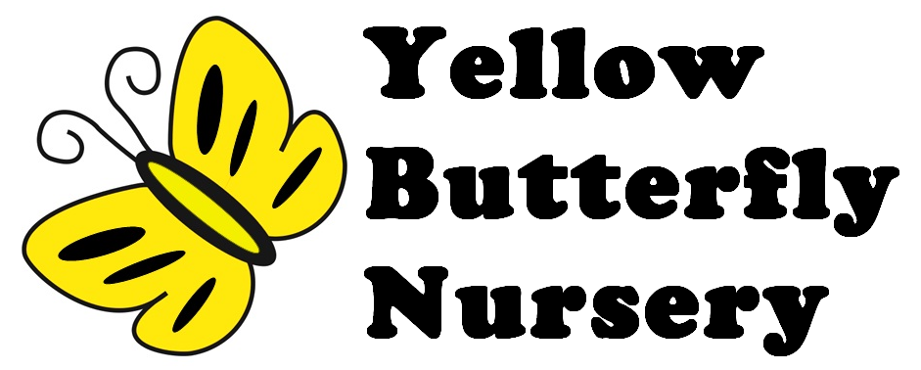

**Childcare Registration and Agreement Form**

Please complete this form and return it with the registration fee (£50) and a refundable deposit of £100 for part time children and £200 for full time is required .

This form must be completed by someone who has parental responsibility.

Bank details

Natwest

Yellow Butterfly Nursery Ltd

Bank -Natwest

Account no -10267409

Sort code -60 02 60

**Family Details**

|  |  |  |  |
| --- | --- | --- | --- |
| Child’s full name | |  | |
| Preferred or familiar name | |  | |
| Date of birth | |  | Birth certificate Presented? |
| Parents /  carers names | Father |  | |
| Mother |
| Other (Specify) |
| Parent/carer addresses  *Please provide names and addresses for each parent and carer known to the nursery (continue on separate sheet if required)*  *Please indicate your child’s usual address* | |  | |
| Other people allowed to  collect your child?  *Must be over 16 years of*  *age* | | Names and addresses | |

**Contact Details**

|  |  |
| --- | --- |
|  |  |
| Mum mobile or work number | Mum email address |
| Dad mobile or work number | Dad email address |
|  |  |
| Email address  (for your invoice to be sent to) |  |
|  |  |

**Legal Responsibility and Contact Details**

|  |  |
| --- | --- |
| Who has Parental Responsibility for your child?  E.g. the parent/carer who is your child’s main carer(s) | Names |
| Who has Legal Contact with your child?  E.g. a parent who lives at a different address | Names |

**Daytime Emergency Contact Details**

|  |  |
| --- | --- |
| Mother | |
| Name | Telephone no: |
| Father | |
| Name | Telephone no: |
| 1st alternative contact (required) | |
| Name and relationship to child | Telephone no: |
| 2nd alternative contact (required) | |
| Name and relationship to child | Telephone no: |

**Health Information**

|  |
| --- |
| Doctor’s name, address and telephone no: |
| Health Visitors Name and telephone no: |
| Does your child have any special health requirements? |
| Any known allergies ?(e.g. food, animals, plasters, medication, etc) |
| Does your child have any special dietary requirements, preferences or food  allergies? |
| Are all childhood vaccinations up to date? |

|  |  |
| --- | --- |
| Please sign that you are willing to give your consent for | Signatures |
| Outings |  |
| Holding personal information (paper and computer based) |  |
| Sharing information with other professionals, e.g. Health Visitor or Speech therapist |  |
| Photography to be used in-house only,  e.g. photo observations for child’s EYLOG app |  |
| Photography to be used in nursery publicity material, including on the internet (children’s names will NOT be used on any website or in any publicity) |  |
| First aid and emergency medical treatment, including the administration of Calpol should your child’s temperature rise suddenly above 39°C |  |
| Use of child’s own provided sun cream or a named brand supplied by the nursery |  |
| Use of plasters |  |

**Consent Information**

**Other Information**

|  |
| --- |
| Other languages used at home: |
| Ethnic origins |
| Festivals celebrated at home: |
| Details of any other settings or childcare attended: |
| Details of any other agencies or professionals working with your child and their role: |
| Any other details or information it may be useful for us to know? *E.g. What your*  *child likes, what their fears may be, any special words they use, what comforters*  *they may need and when.* |

**Childcare Requirements**

|  |  |  |  |  |  |
| --- | --- | --- | --- | --- | --- |
| **Required**  **Start date?** | Please mark the days and any extra  services you require below | | | | |
| AM Session (8:00 – 13:00) | Mon | Tue | Wed | Thur | Fri |
| PM Session (13:00 – 18:00) | Mon | Tue | Wed | Thur | Fri |
| Full day (08:00 – 18:00) | Mon | Tue | Wed | Thur | Fri |
| Extended session (07:30 to 18:30) | Mon | Tue | Wed | Thur | Fri |
| Nursery lunch required? | Mon | Tue | Wed | Thur | Fri |

**Other Information**

|  |  |  |  |
| --- | --- | --- | --- |
| How did you hear about Yellow Butterfly? Please tick appropriate box | | | |
| Magazine | Children’s Info Service | NHS Staff Info | Flyer |
| Website | Recommendation | Sign outside | Other |
| Did you look at any othernurseries? | | Why did you choose Yellow Butterfly? | |

**Important**

We ask that you keep us informed of any changes to your details.Periodically we may ask you to confirm your details for our records.

**Yellow Butterfly Nursery Terms and Conditions**

Admission

A completed Childcare Agreement Form and Registration fee and deposit are required to secure your child's place.

Registration Fee and Deposit

The registration fee of £50 covers administration and settling sessions. A deposit of £100 for part time place and £200 for full time place is required at time of booking. The deposit will be refunded by the 20th day of the following month of your child’s leaving date, providing a minimum period of three months attendance and appropriate notice has been given.

Fees and Invoices

Childcare accounts are payable monthly, in advance for a calendar month of childcare. Accounts are payable by standing order, card or cheque made payable to "Yellow Butterfly Nursery". We also accept childcare vouchers. We can apply on your behalf for the Free Entitlement from your local LEA (more information will be given to you when your child becomes eligible).Invoices will be issued in the week preceding the start of the month and will be due for payment on the 1st of the month. Unless there is a prior arrangement, a charge of £20 will be made for fees outstanding after 5th of the month. Cheque payment will not be accepted after 3rd of the month, credit/debit card payment will be required. Any parent or carer whose fees remain unpaid after 5th of the month, without prior agreement of the Nursery Manager, risks their child’s place at the nursery being withdrawn. Any payments that are cancelled or returned from the bank will incur a £25 administration charge, and the parent/carer will be asked to pay by credit/debit card in future.

No refunds are given for sessions missed due to sickness or holidays or unavoidable nursery closure. Be aware that the number of days childcare provided each month may vary.

All bank holidays and inset days are charged for. Christmas and New Year closure will be deducted from December and January invoices accordingly. Un-notified late collection will be charged at a rate of £5 for every 5 minutes to cover emergency staffing and other arrangements. In case of default on payment the nursery reserves the right to apply a £50 administration fee for preparation of court papers and interest will be charged at 8% above the bank’s prevailing base rate. The nursery is not responsible for collection of fees from any

third parties except in the case of statutory nursery education funding allowance. The nursery will give parents and carers one month’s notice of increase of fees which will normally be reviewed in April.

Opening times

The nursery sessions run from 8.00 am to 6.00pm Care between 6 pm to 6.30 pm and 7.30 am to 8 am is by arrangement only. The nursery is open 51 weeks of year except bank holidays, Christmas & New Year closure and occasional inset days. The inset days (staff training day) in the academic year will also be charged for whilst the nursery is closed to children; minimum of two months notice will be given for this day.

Termination, cancellation and change of sessions

One month notice is required by either party for any change of sessions or termination of agreement. If parents choose to leave prior to the end of their notice, fees are non-refundable. The minimum period for any permanent change of sessions is one month. If the notified start date is changed by the parent, we reserve the right to charge from the original start date notified on the Agreement form. The nursery reserves the right to terminate the Agreement with immediate effect in case of non-payment of fees, or if a parent, carer or child displays abusive, threatening or otherwise inappropriate behaviour, or for any other reasonable cause. Intimidation or abuse of our staff will not be tolerated and may result in immediate termination. In all other cases the standard notice period of one month will apply.

Insurance

The nursery has extensive insurance cover for nursery based activities and outings. Details of the insurance may be requested from the nursery manager. The Certificate is displayed in the nursery.

Personal property and belongings

The nursery cannot be held responsible for any loss or damage to any parent’s, carer’s or child’s property or belongings. Every reasonable effort will be made by the nursery staff to ensure that property or belongings of any parent, carer or child is not damaged. Please ensure your child’s clothing is clearly labeled and we suggest that all toys, books and equipment are left at home.

Liability

The nursery accepts no liability for any losses suffered by parents arising directly or indirectly, as a result of the nursery being temporarily closed or the non-admittance of your child to the nursery for any reason. We accept no responsibility for children whilst in their parent’s care on nursery premises. We will not be liable to parents and/or children for any economic loss of any kind, for damage to the child’s or parent’s property, for any loss resulting from a claim made by any third party or for any special, indirect or consequential loss or damage of any kind.

Accidents and illness

The nursery reserves the right to administer first aid and any emergency treatment as required. Parents will be informed of all accidents and will be asked to sign an Accident record form. If emergency treatment at hospital is required the nursery will make all reasonable attempts to contact the parents but if this is not possible we are authorized to act on behalf of the parents and authorise any necessary emergency treatment.

We will administer prescribed medicines only if parents have completed a Medicine Consent form.

We may require parents to withdraw their child from nursery in the event that they require special medical care or attention which is not available or refused by the parent, or it is considered that the child is not well enough to attend nursery. We may also ask parents to withdraw their child from the nursery if we have reasonable cause to believe that the child is suffering from or has suffered from any communicable disease or infection and there remains a danger that other children may contract such a disease or infection. Please refer to our Health Illness and Emergency Policy regarding exclusion and incubation periods by which we are bound. Parents must inform the nursery if the child is suffering from any illness, sickness or allergies before attending the nursery. The nursery is mindful of the needs of working parents and will endeavour to provide as much continuity of service as possible within the recommendations of the Health Protection Agency by which the nursery is bound.

Agreement

These Terms and Conditions represent the entire agreement and understanding between the parents (including other carers) and the nursery. Any other understandings, agreements, warranties, conditions, terms and representations, whether verbal or written, expressed or implied are excluded to the fullest extent permitted by law. We reserve the right to update / amend these Terms and Conditions at anytime. One month notice will be given of any changes made. The nursery is operated by Yellow Butterfly Nursery I have read and understand these Terms and Conditions and agree to be bound by them.

Signed (parent) ................................................................................

Print name: ......................................................................................

Date: ...............................................................................................

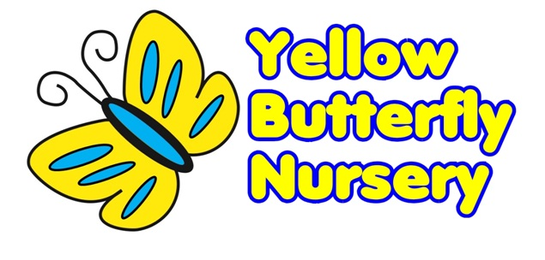

# Yellow Butterfly Nursery Photography Consent Form for the use of images of children

Child’s Name: __________________________________

Date Of Birth: __________________________________

Parent’s/ Carer’s Name: _______________

To comply with the Data Protection Act 1998, we must ask your consent before the nursery records any images of children (aged under 18).

**Please answer the questions below and then sign and date the form below:**

1. May we use your child’s image on Yellow Butterfly Nursery Website?

Yes/No

1. Are you happy for your child’s image to appear in the media i.e. Yellow Butterfly Nursery Facebook Page/ Yellow Butterfly Nursery Instagram?

Yes/No

Please make sure you have read and understood the Conditions of Use prior to signing this form.

Signed: ____________________________________________

Name: _______________________________________________________________

Telephone number: ___________________________________

Relationship to child: __________________________________

Date: ______________

Conditions of use

1. These forms are valid for five years. If you change your mind about giving consent to any of the above during this period, please inform Yellow Butterfly Nursery immediately.

2. If we decide to take photographs for any other purpose than those listed here, we will contact you again to ask for your consent.

3. Images of children will be stored securely. Please be aware that Yellow Butterfly Nursery has no control over the way external photographers and the media store images.

4. We will not include any personal details such as home phone numbers or email addresses of children in our publications, without asking you for specific separate permission first.

5. We will only use photographs of children who are suitably dressed, in order to reduce the risk of misuse.